1. **Introduction and Motivation**

Wherever a person goes in the high population density areas, a parking issue will most likely be present. That is because in this modern world, people tend to have their own vehicles. As the number of cars in the modern world increase, more parking spaces are demanded. There is no difference in the case of Qatar as it is becoming a crowded country and one of those crowded places is Qatar University (QU). The number of students is increasing drastically each year in QU and as Qatar University students, we are motivated to come up with a solution for this problem.

* 1. **Problem statement**

In Qatar University (QU), there is an ever-increasing number of students annually, which leads to an increase in the number of vehicles arriving at the campus as well. According to the Ministry of Education’s 2012 statistics, the number of students attending QU has exceeded ten thousand students [1] and is only increasing with each passing year, not to mention the number of staff and faculty that also need parking for their vehicles. Today, the number of students in Qatar University has reached more than 20,000 [2]. As a result, there has been a rapid increase in the number of people and their vehicles on campus, and with the limited available parking spaces, parking problems were bound to exist.

Finding a parking space in Qatar University has become a real problem in recent years and has turned into a topic of concern among students and staff of the University. To assess the severity of the parking problem, an online survey was shared with Qatar University students. We will share and explain the results throughout this section. The first question answered by Qatar University students in our survey in Figure 1-1 proves that there is a real problem in finding a vacant parking spot inside the campus.

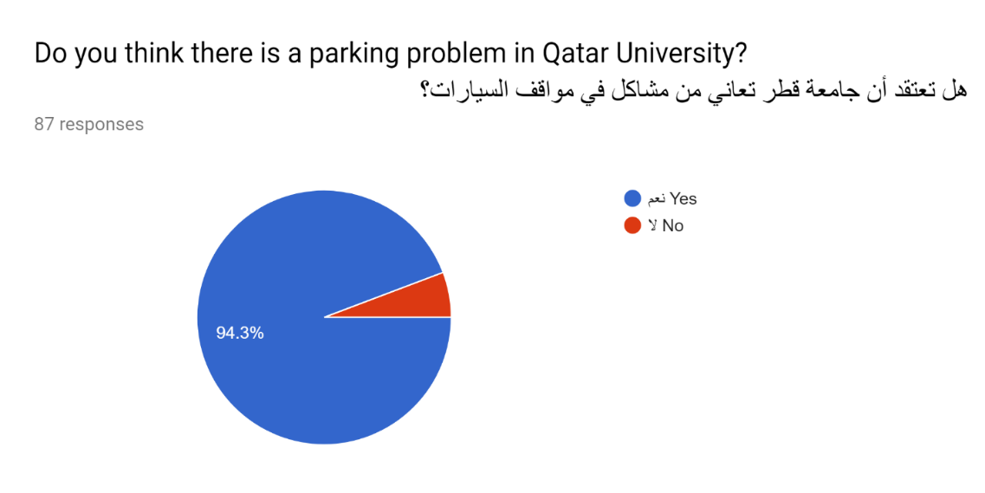

**Figure 1‑1: Statistics from Survey**

**Local media**

The problem has surpassed the students' conversations to become the talk of the press and media in Qatar. Figures 1-2 up to 1-7, show Qatari newspapers Al-Raya, Al-Watan, Al-Arab and Al-Sharq’s headlines about the parking problem at Qatar University and its impact. The articles highlighted that the effects of this problem were not only limited to students and staff, but also impacted the university’s visiting guests who come for events, ceremonies, seminars or conferences.

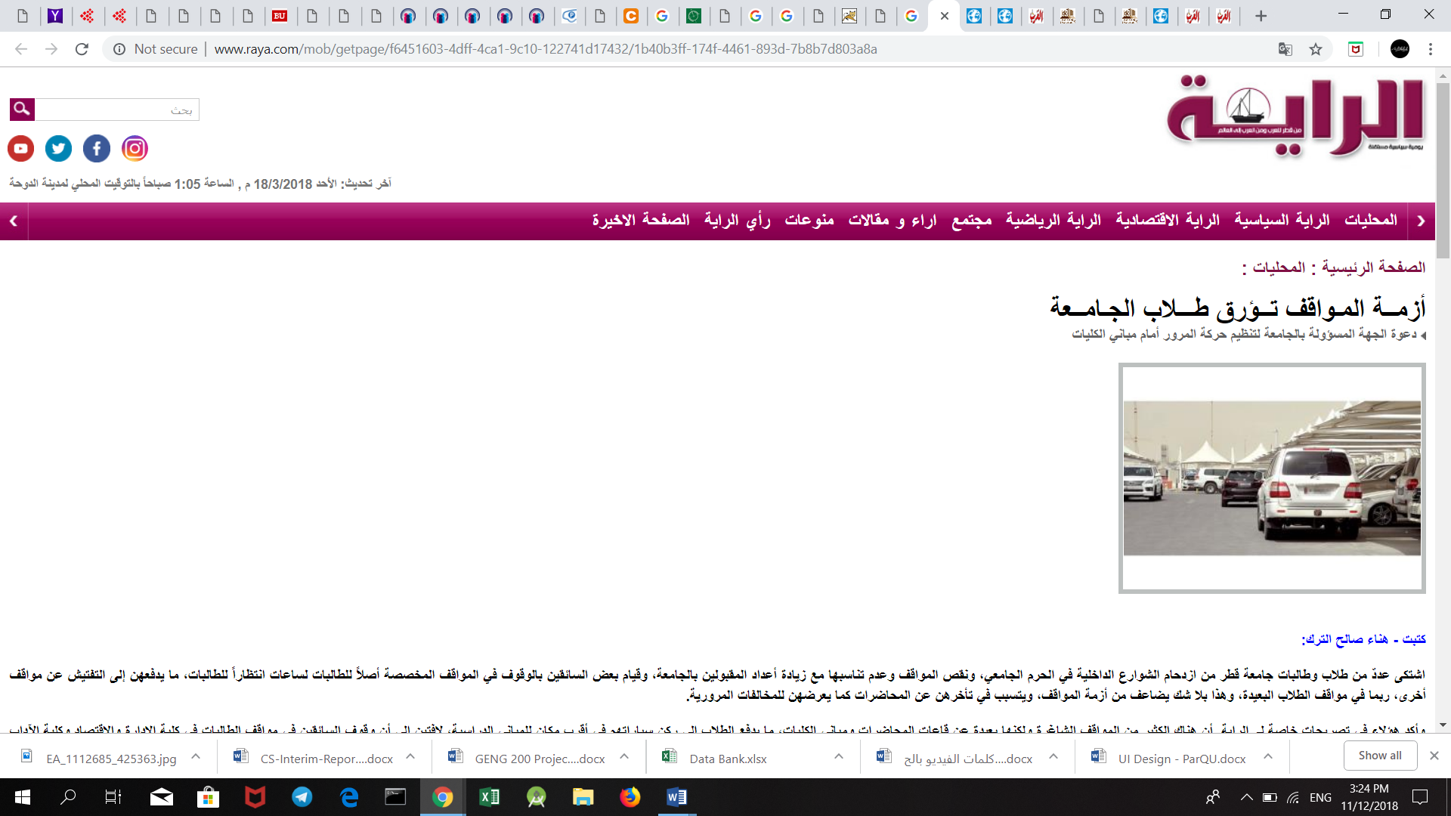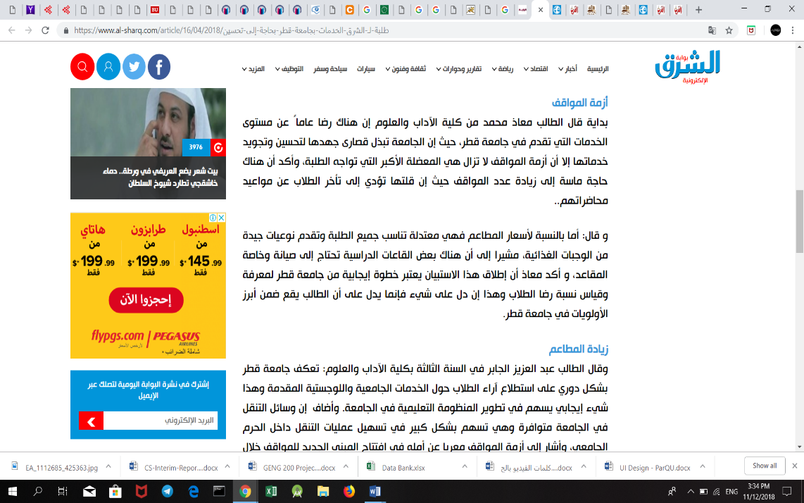

Figure ‎1‑2: Article from Al-Sharq Newspaper

Figure ‎1‑3: Headline from Al-Raya Newspaper

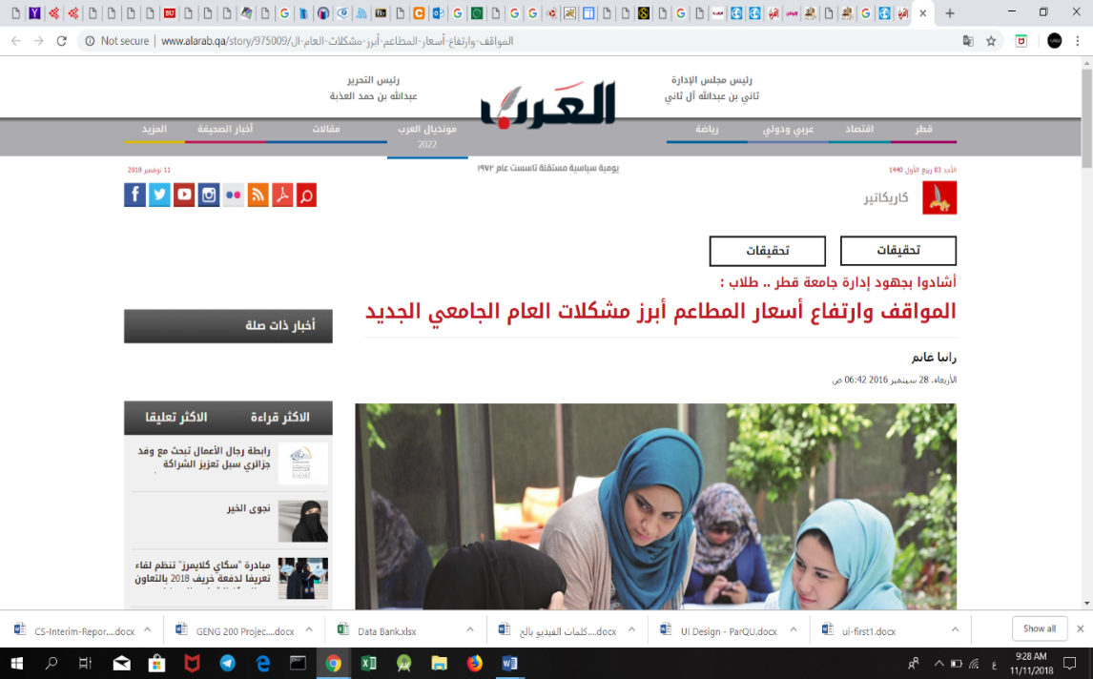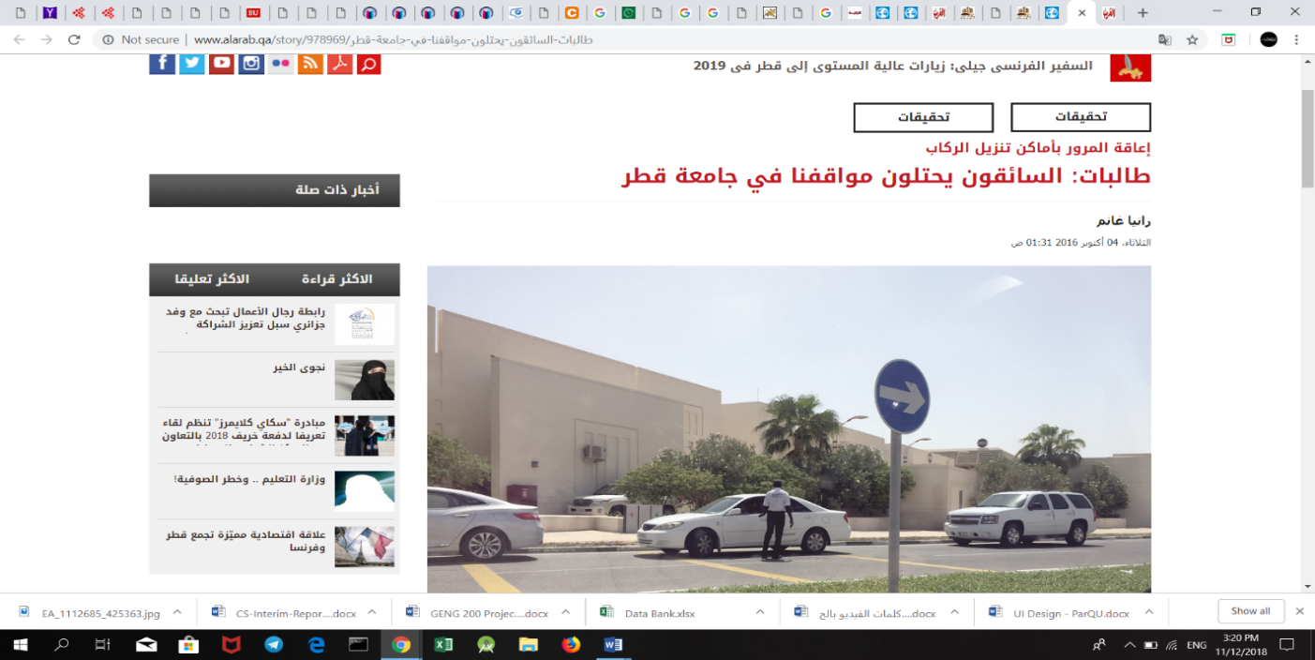

Figure ‎1‑4: Headline from Al-Arab Newspaper

Figure ‎1‑5: Headline from Al-Arab Newspaper

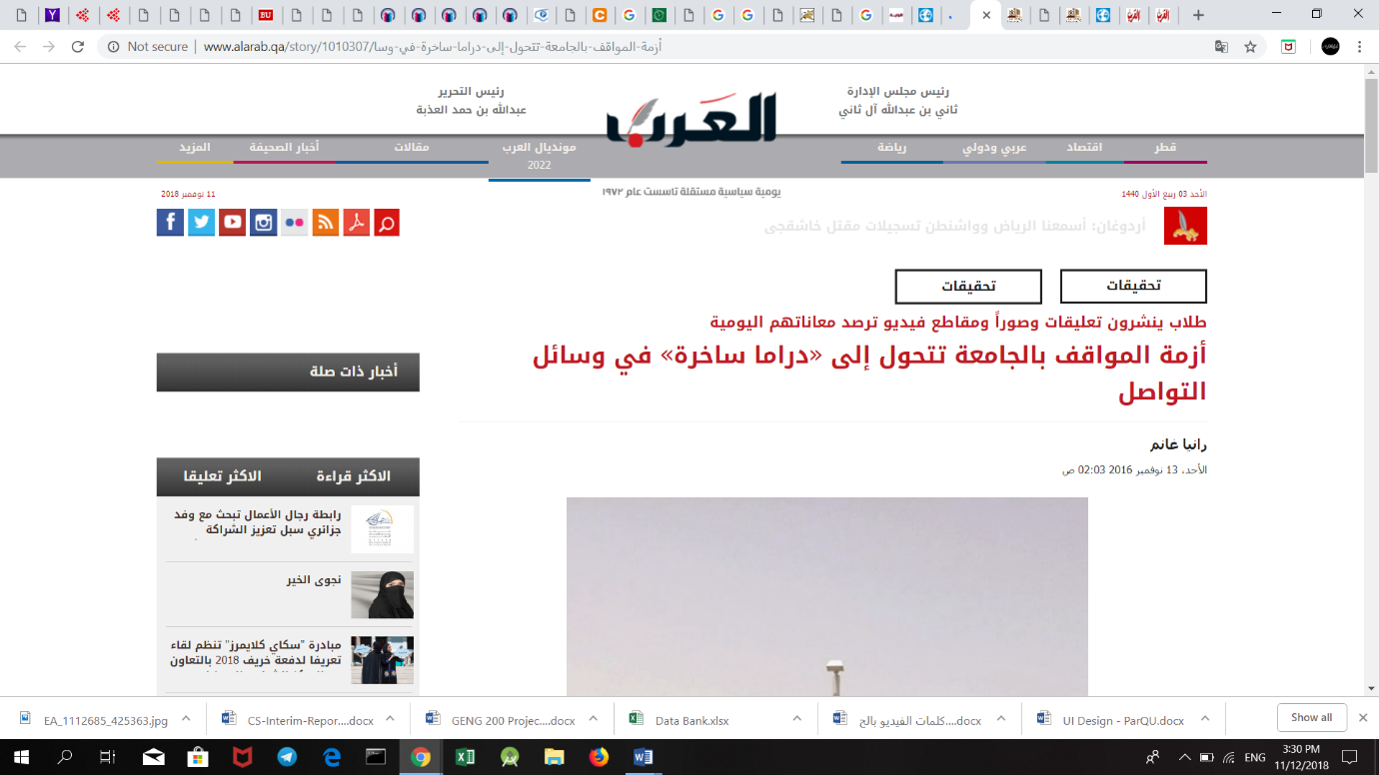



Figure ‎1‑6: Headline from Al-Arab Newspaper

Figure ‎1‑7: Headline from Al-Watan Newspaper

Additionally, frustrated students have taken to social media to air their criticism on the ongoing crisis of parking areas at Qatar University [3]. Students circulated comments, pictures, and videos that represent their daily suffering from the lack of the parking spaces allocated to them in the university.

Tens of sarcastic and critical tweets pointed out this issue as displayed in Figures 1-8 until 1-11 below.

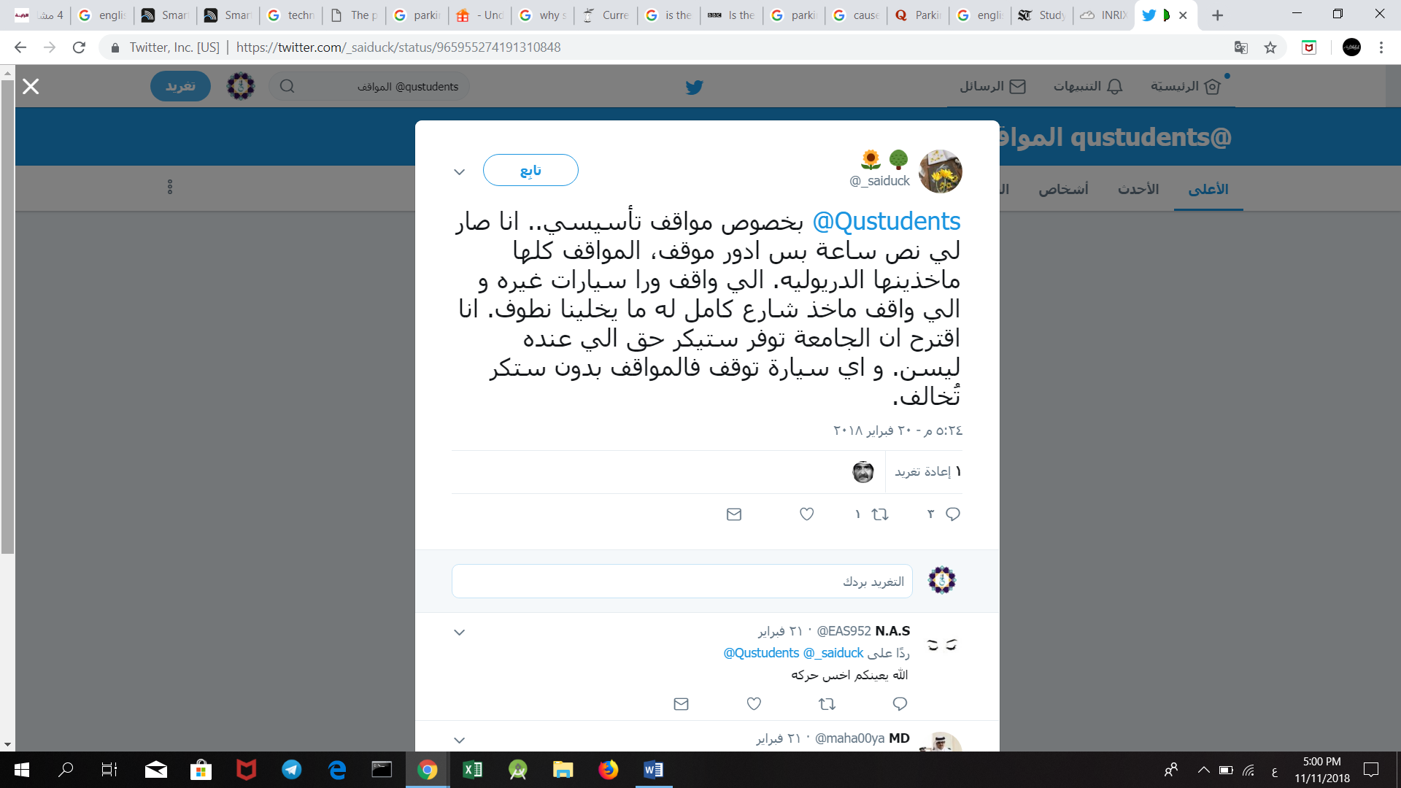

Figure ‎1‑8: Tweet from Twitter about the parking problem

Figure ‎1‑9: Tweet from Twitter about the parking problem

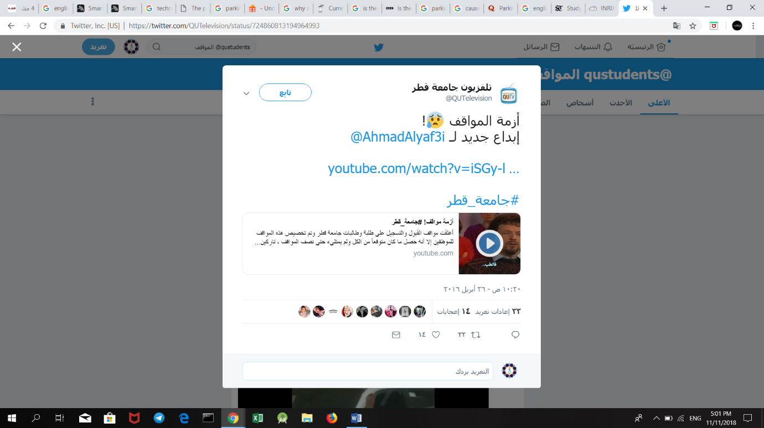

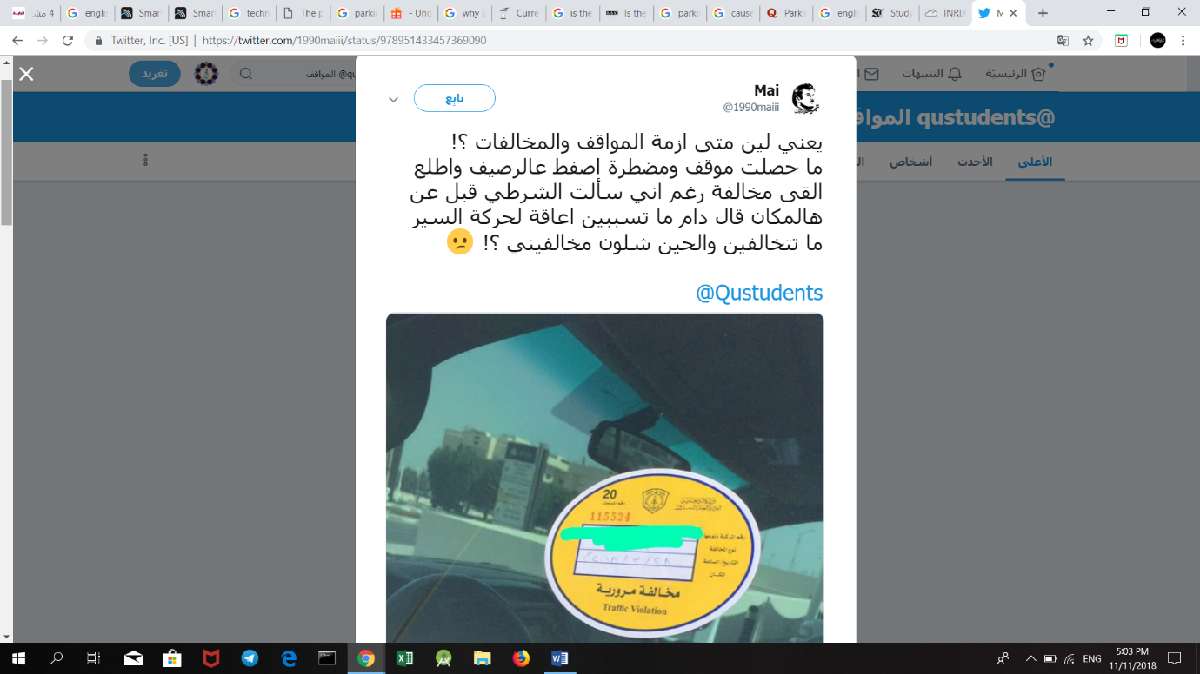

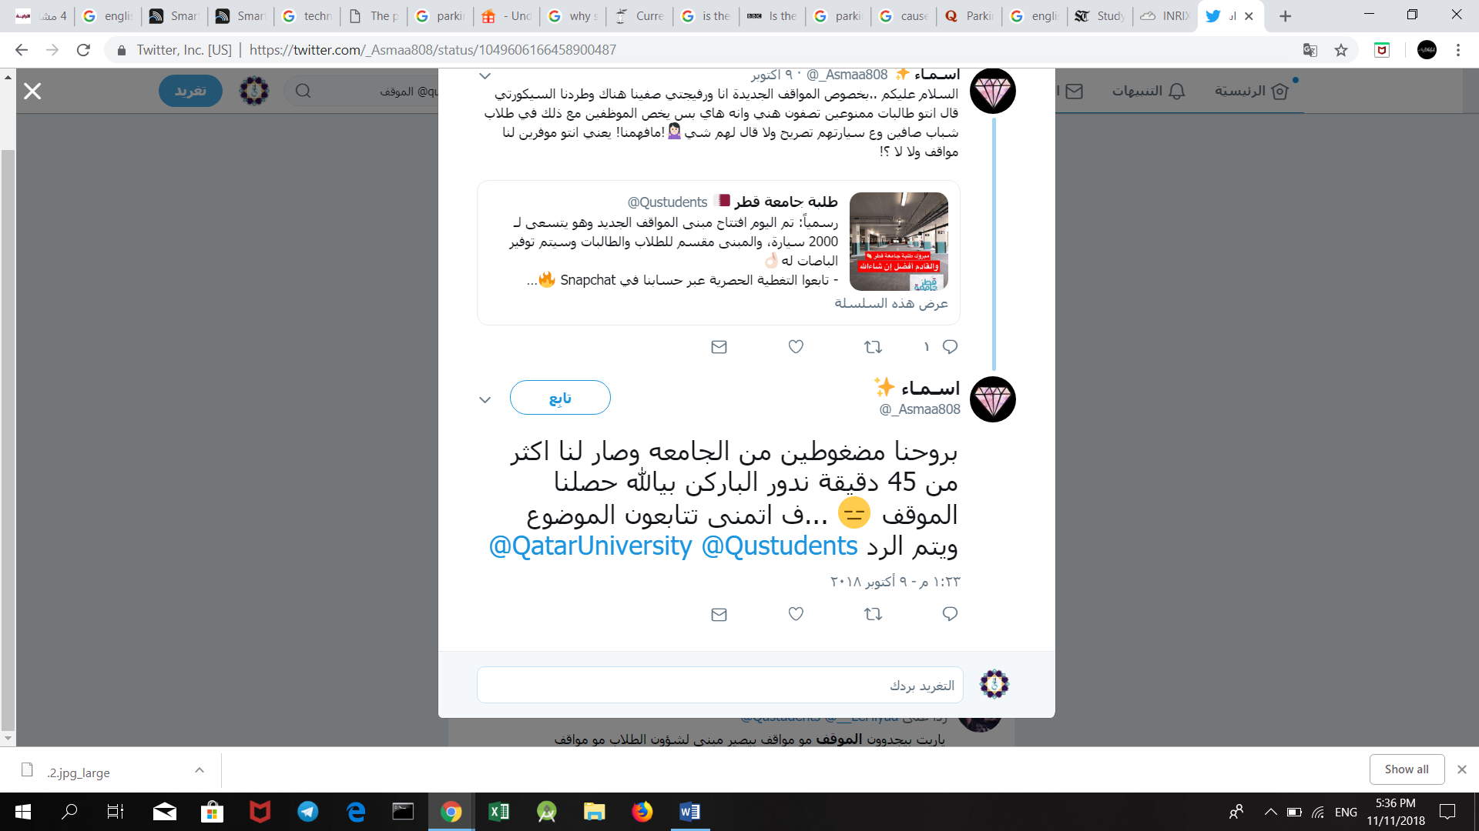

Figure ‎1‑10: Tweet from Twitter about the parking problem

Figure ‎1‑11: Tweet from Twitter about the parking problem

**Impact**

People looking for an empty parking spot is one of the major causes of congestion and a waste to the university attendants’ valuable time. As shown in Figure 1-12, more than 60% percent of the students who responded to our survey reported that they take more than 15 minutes just to find a vacant parking spot. Furthermore, the parking problem causes more fuel to be consumed while driving around parking lots. The increase in fuel consumption wastes the vehicle owner’s money and leads to more CO2 emissions.

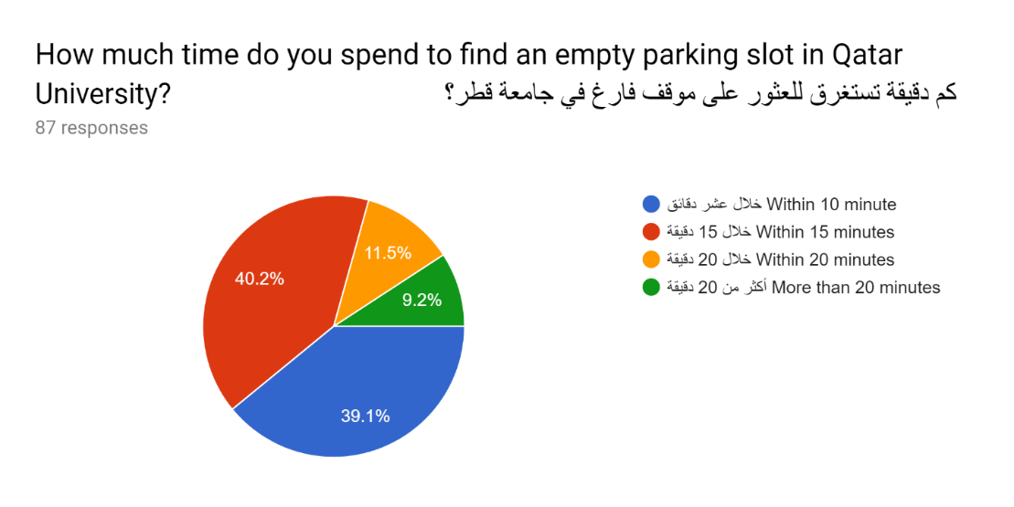

**Figure 1‑12: Statistics from Survey**

According to an article in Al-Watan newspaper [4], a number of Qatar University students complained about the university’s lack of balance between the increase number of students’ admissions and the limited number of parking areas. This makes the students to spend more time searching for a vacant parking slot and arrive late to their lectures. A considerable number of students also declared that they are forced to come to the university early, so they can get a parking slot for their cars [5].

Additionally, frustrated drivers are forced to park in illegal parking places which in turn leads to an increase in the number of traffic violations and accidents inside the campus. Figures 1-13 and 1-14 below show examples of illegal parking where cars are parked over sidewalks and on the grass field.

A truck on a city street

Description generated with high confidence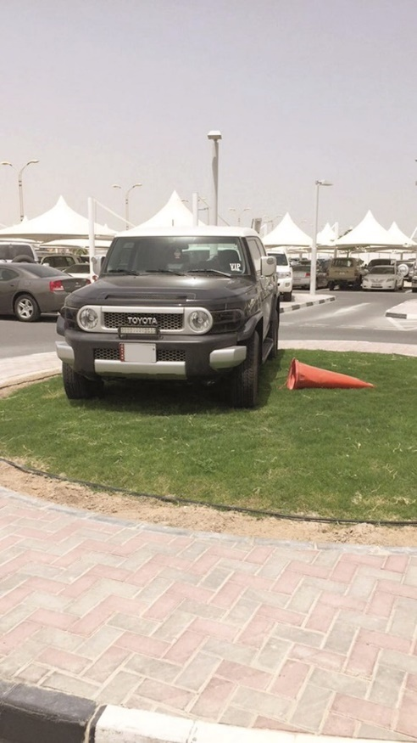

Figure ‎1‑13: Vehicles in Qatar University parked illegally

Figure ‎1‑14: Vehicles in Qatar University parked illegally

In the end, the university’s reputation is negatively affected with the crisis of parking areas, because it is the first thing that guests see when visiting, and to students and staff the way they start their day. If the parking situation continues to be the same, it would hugely impact the image of the university in people’s minds.

**Technical challenges**

The technical challenge we think we will face doing our project:

1. Ultrasonic sensors might not detect a car if it is not close enough.
2. More financial and physical resources will be required to scale the system.
3. Internet connection heavily affects keeping the system in real time
4. Keeping up to date with the latest Android version.
5. Developing a scalable and extendable, user-friendly application with high level of performance and services.
   1. **Project significance**

Based on the above section, additional parking spaces are desperately needed on campus. If there are proper parking places, then traffic problems in Qatar University would be less apparent.

However, even with limited parking spaces, a parking system is needed to organize and utilize the parking area resources. The parking system can also guide the vehicle owners at the university to reduce traffic overcrowdings by suggesting different routes at the campus roads. The system is made more efficient as vehicle owner’s search time is significantly reduced due to the information provided by the smart parking system. This also means that the traffic congestion can be significantly reduced, and the university could even charge vehicle owners when they park illegally.

A smart parking system will not only be beneficial for Qatar University’ attendants, but also is considered valuable for the car parking operators and customers as well as the environment [6][7]. For the parking operators, the data gathered via the implementation of the parking system can be used to predict future parking patterns. Pricing strategies can also be manipulated based on the information gained to increase the university’s profit. In terms of environment protection, the level of pollution can be reduced by decreasing cars emission in the air [6].

* 1. **Project objectives**

1. To design and implement a system that can manage parking areas.
2. To use Ultrasonic Sensor and RFID Reader to collect data.
3. To use Arduino to receive data from used sensors and send it to the Firebase for storage.
4. To design an Android application and a website.